

School of Computer Science and Engineering

CZ 3005 Artificial Intelligence

Lab Assignment  
(Kid’s Day at School)

By: Edwin Khoo Ding Neng

Matriculation Number: U1721633J

Tutorial Group: TSP2

Wednesday, Nov 13th, 2019

# **Introduction**

Assume that the prolog script is a parent, trying to know about a kid’s day at school. The prolog script should converse intelligently with the kid as follows. The prolog script should ask a question to the kid that kid can answer either a yes or no. Depending on whether the answer is yes or no, prolog script should ask a related question or another random question. For example, if the kid says yes to whether it ate or not, the query can be a food item, or whether the kid used fork or spoon, or whether the kid washed hand. Similarly, related to games.

# **Implementation**

In this assignment, kid’s day at school will be implemented with Python GUI as a bridge to the Prolog script. With the use of Kivy, I have designed a simple Python GUI in order to present the Prolog script a better interaction with the user instead of the troublesome command line interface. With the use of the popups feature, the GUI was designed to display a question regarding the kid’s day at school with a yes, no button for kid’s answer. The logic behind the choosing of the topics will be done by the Prolog script which ask related question or random question based on the yes no answer from previous topics, till the end of list.

# **Instruction for Installation**

1) Install python 3.7.4  
<https://www.python.org/downloads/release/python-374/>

2) Install pyswip 0.2.9  
<https://pypi.org/project/pyswip/>

3) Install Swi-Prolog version 7.6.4 (anything below 8.0.0)

<https://www.swi-prolog.org/download/stable>

4) Install pip by going to this link:  
 <https://pip.pypa.io/en/stable/installing/>

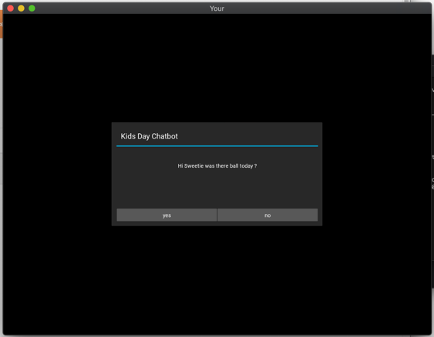5) Run: pip install kivy

5) cd to the file path location

5) run the python file

6) Kivy GUI should pop up like this

# **The Interface Program: KDbot.py**

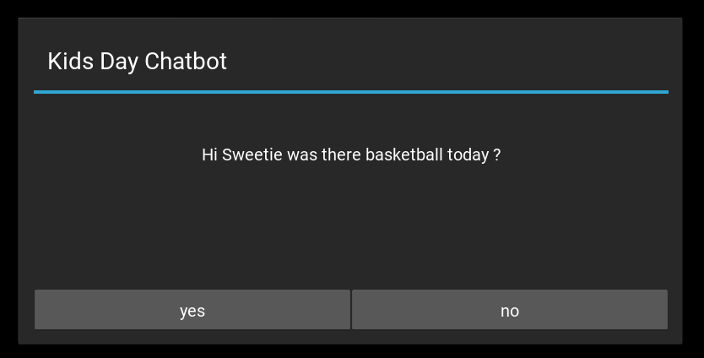

The above illustration is the GUI when the python file is first executed. This is the first question that will be prompt to the user. I will briefly, explain how the code of the GUI and the prolog works to generate this first interface below.

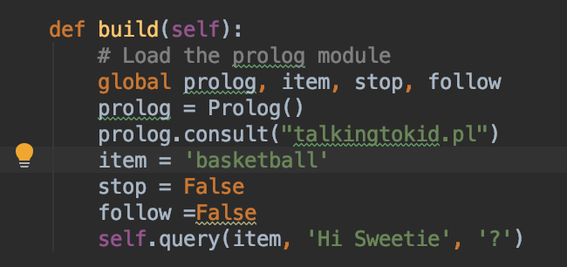

1. In the *build()* of the class KDbotApp, it declare and initialize several variables and load the *prolog* module that calls and consult the prolog file *“talkingtokid.pl”.* The *prolog, item, stop and follow* variables are declared as global for use in the other functions so as to retrieve the response from the popup dialog later on. Then, the *query()* is called with the starting *item* and a “Hi Sweetie” and “?” prefix and suffix respectively as it’s the first question.



1. This *query()* that receives parameter of *item*(“basketball”)*, begin*(“Hi sweetie”)and *end*(“?”). They are joined together in the following format({} was there {} today {}) into a full string and pass to *callpopup()* as a *question. callpopup()* then initialize the class *MessageBox* with parameters *titleheader=”Kids Day Chatbot”, message=question* and *options={“yes”:”printyes()”, “no”:”printno()”}.* To put it simply, what this does is to generate a popup GUI message box with a custom title, message and 2 yes and no buttons which will call *printyes()* and *printno()*.

**User response by clicking on yes**

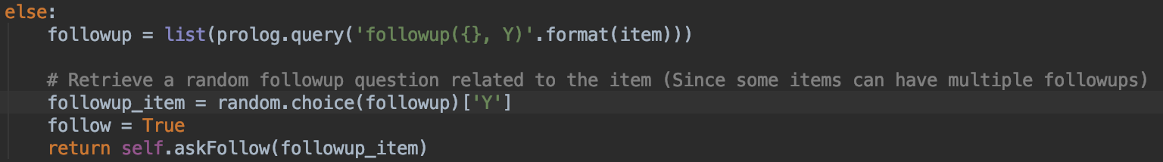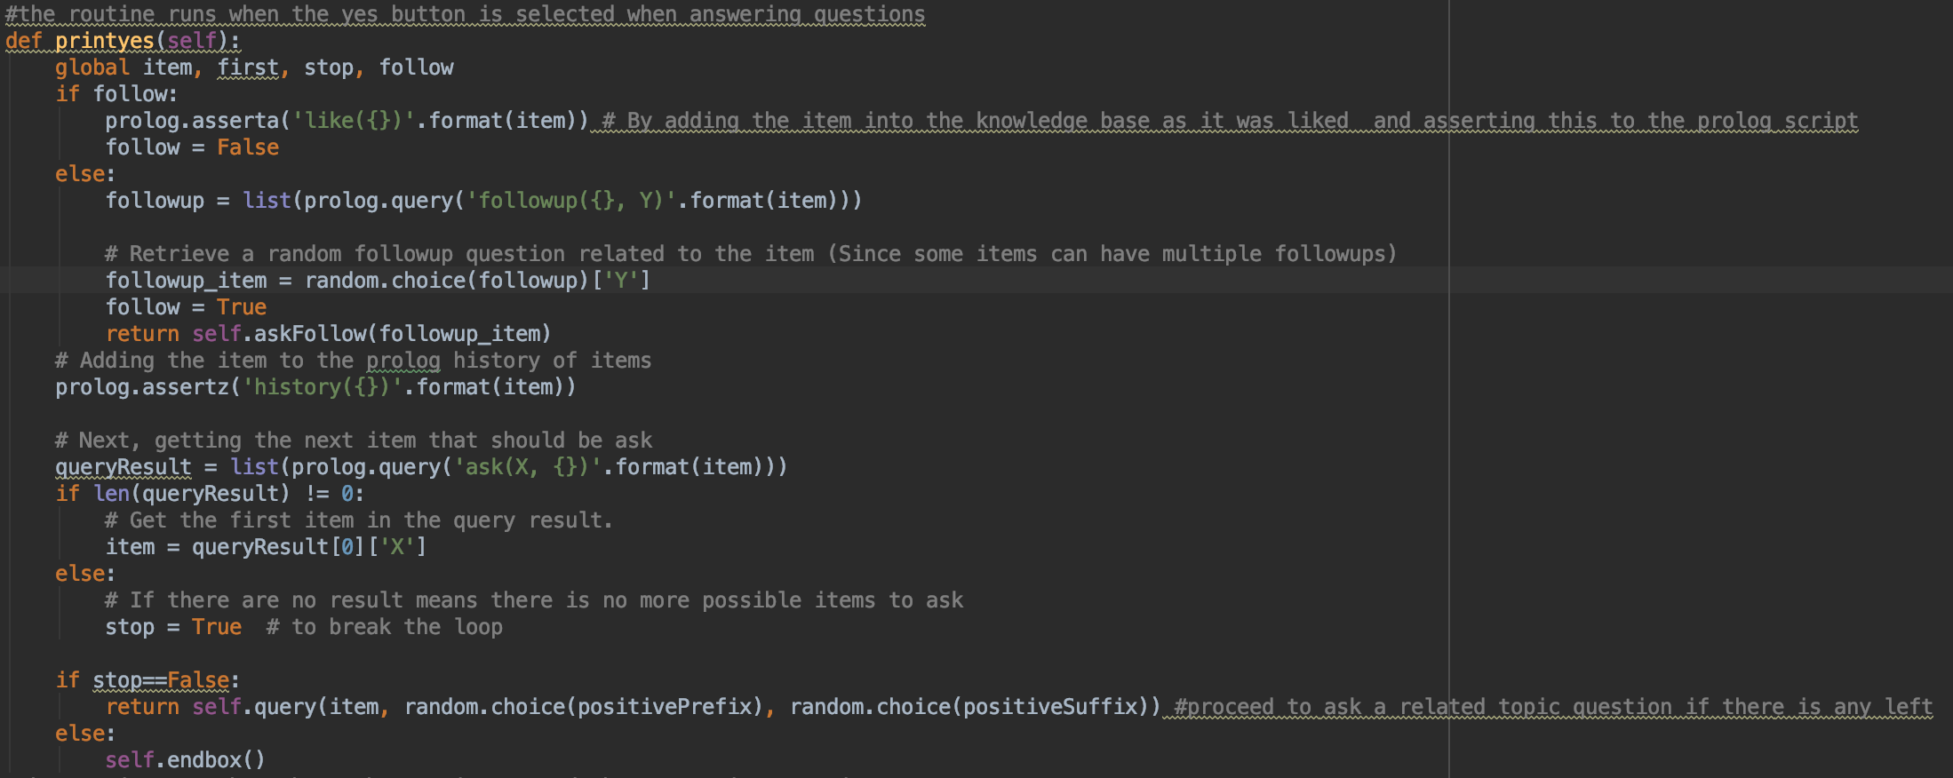

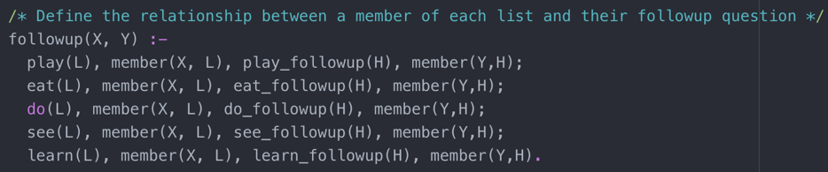



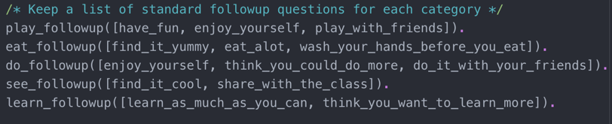



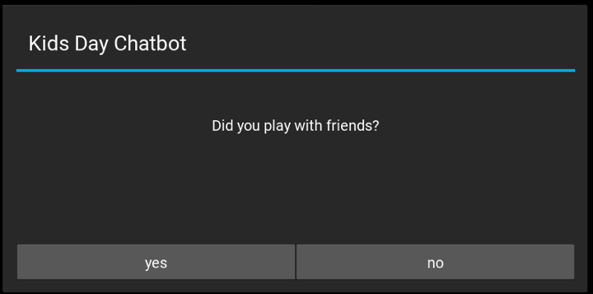

The above is the sequence where the user have clicked on the yes button for the previous question. Therefore, it will call the *printyes()*. For this portion, we will focus on the follow up question generation and GUI creation, since yes is clicked it show that the kid is able to share on his experience on the topic.

1. So, within *printyes()*, it first checks whether the variable *follow* is true or false. In this case, since the first question is not a follow up question, *follow* is false. Therefore, the code jumps to else loop.
2. Firstly, it queries the prolog file for a list of follow up items satisfying the *followup(X, Y)* rule where *X* is basketball. In this case, *play(L) & member(X,L) & play_followup(H) & member(Y,H)* has to be satisfied.
3. So, *play(L)* is basically getting any variable *L* within the *play* list so we shall not discuss it. Next, it checks if *basketball* is a member of *play* list with the two predicates highlighted in the illustration above, which it does.
4. So, *play_followup(H)* gets any variable H in the *play_followup* list checks if it is a member of *play* list with the two predicates highlighted in the illustration above, which it does*.* The prolog query will then return all the items in the *play_followup* list and store it into a list variable *followup* in python. The item from list is extracted and randomized using *random.choice()[‘Y’]*. And *follow* is set true since this is currently a follow up question.
5. Lastly, *askFollow()* is called and within the method, it *callpopup()* which I explained before is used to create the GUI by initializing a MessageBox class. However, this time, the format of the message set is “Was it {}?” (default for follow up questions), in this case item was “play_with_friends”, then .replace(“_”,” ”) is used to replace the underscores with spaces Therefore, the GUI is as displayed as shown above.

**User response yes on follow up question**



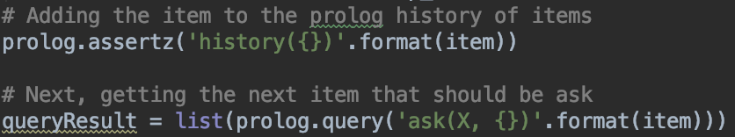



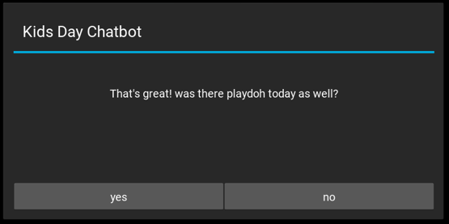

The above is the sequence where the user clicked yes for the follow up question. Redirecting into the *printyes()* again. This time, *follow* is true since it is an answer to follow up question.

1. Since the kid experienced the activity and liked it from the response of the follow up question, the *item* is asserted to the prolog script as a *like(basketball)* fact. Then the *follow* is reassigned back to false.
2. The item is then asserted as a *history(basketball)* fact in order to prevent asking same topics. Next, the prolog queries for the list of items satisfying *ask(X,Y)* predicates (Y being basketball in this case).
3. So, in this case the predicate highlighted will be used since *like(basketball)* is a fact. So it will find variables of X, where *related(X, basketball)* is true and *history(X)* is not a fact.
4. *related(X,Y)* basically finds a variables X which is a member of the same list as Y. I have explained the logic of member in the above so I won’t go much into it.
5. After obtaining the list of items satisfying the prolog predicates, the python script will make sure list is not empty and extract an item using *item=queryResult[0][‘Y’]*. And this *item* is used to craft the *message* for the next *MessageBox* popup with the *positiveprefix* and *positivesuffix.* Display of GUI is as shown above.

**User clicked no on the response**

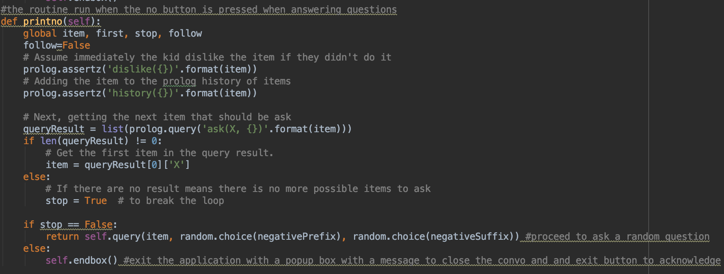

1. Other than the above hightlighted, the basic logic for the no reponse is similar to the yes reponse. Firstly, it will set follow as false, and since kid doest like or experience the item, it is assume he dislike it. Therefore, the item is asserted as dislike() fact and history fact.
2. For the prolog queries *ask(X,{})*, this time the second predicate will be used since the kid doesn’t have a *like()* fact regarding the item. So, it will just take a random *item* from any list which is not related and wasn’t asked before as a topic



1. The message will be crafted with the *item, negativepreffix* and *negativesuffix*. The following GUI will be generated.

So, the above yes and no will run as a loop until the list of topics are exhausted. This is achieved by a recusive call by the *printyes()* and *printno()*.

**queryResult list is empty**



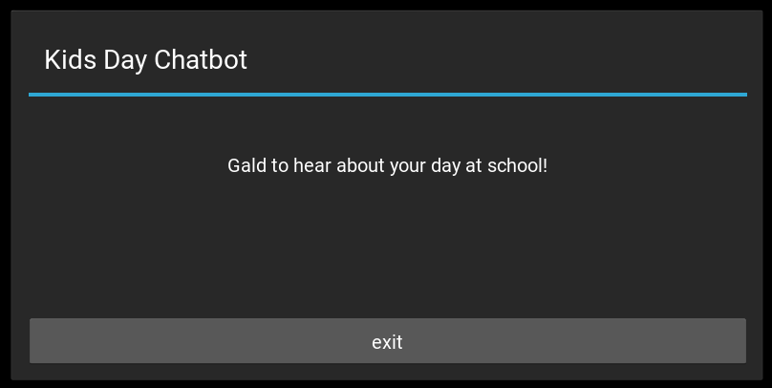

1. The *stop* variable will be set as true and the *endbox()* will be called. Basically, what this does is initialize a *EndBox* class (Class creating a popup similar to *MessageBox*) with the following message *“Glad to hear about your day at school!”* and an button, *exit* which calls *callexit()* to close the application when pressed with the following command *App.get_running_app().stop()*